
Year 11 General Human Biology
Task 6: Supervised written – Immune System (10%)

RESULT
/ 40

Task 6

TYPE: Supervised Written
CONTENT: Immune System

WEIGHTING: 10%

Student Name: ____________________________
Due date: ___ / ___ / ______
Teacher: Mrs Cunningham

CONDITIONS:
Must be completed under test conditions in class. This task will be competed individually.
50 minutes allocated
40 Marks

TASK DETAILS:
This task contains four questions with a number of parts to assess the student’s understanding of the content from the science understanding topics cell reproduction, reproductive systems and pregnancy.
Notes/reference materials may not be used during this task.
This task contains a number of question types. You could be required to:
- provide single word, sentence or short paragraph responses
- construct, use, interpret or analyse secondary data, graphs, tables or diagrams
- provide responses making connections, drawing conclusions, constructing arguments, analysing and/or evaluating information.
Your responses may incorporate labelled diagrams or tables with explanatory notes.

Answer all questions in the spaces provided. (TOTAL 40 marks)

Question 1 (TOTAL 18 marks)
In hospitals, there is always a risk that doctors moving from patient to patient may accidently transfer infections and pathogens. To guard against this, it is standard practice for doctors to wash their hands between seeing patients.
- Define the term ‘pathogen’. (1 mark)
___________________________________________________________________________
A hospital decided to investigate whether using disposable gloves, as well as washing hands would provide more protection to patients. The hospital made it compulsory for doctors to wash their hands and wear gloves when moving between patients.
To determine the effectiveness of this policy, the rate of patients contracting infections while in this hospital was compared to that of patients at a hospital where doctors only washed their hands.
The results obtained from the investigation are shown in the able below.
 | Procedure | Infection rate (number/1000 patients)
Hospital 1 | Washing hand and wearing gloves | 9
Hospital 2 | Washing hands only | 12

- On the grid provided below, graph the data presented in the table above. (5 marks)



- Propose a hypothesis the hospital scientists were investigating. (2 marks)
______________________________________________________________________________
______________________________________________________________________________

- Identify the independent and dependent variables in this investigation. (2 marks)
Independent variable
___________________________________________________________________________
Dependent variable
___________________________________________________________________________

- State two variables that should be controlled in this investigation. (2 marks)
______________________________________________________________________________
______________________________________________________________________________

- Write a conclusion for this investigation. Justify your answer. (2 marks)
______________________________________________________________________________
______________________________________________________________________________
______________________________________________________________________________
______________________________________________________________________________

Question 2 (TOTAL 9 marks)

The body’s first line of defence provides non-specific barriers to the entry of pathogens.
- Describe one way each of the following structures protect the body against the entry of pathogens. (4 marks)
Structure | How it protects against the entry of pathogens
Skin
Nasal cavity

The body’s second line of defence provides a non-specific response to pathogens that have entered the body.
Mrs Jones accidentally pricked her right thumb when trimming a rose plant. The injured area became swollen, red and slightly tender to touch.
- Name the type of response Mrs Jones has had to her injury. (1 mark)
___________________________________________________________________________
- Explain why the injured tissue becomes swollen and red. (4 marks)
___________________________________________________________________________
___________________________________________________________________________
___________________________________________________________________________
___________________________________________________________________________
___________________________________________________________________________
___________________________________________________________________________
___________________________________________________________________________
___________________________________________________________________________
The body’s third line of defence is a specific response to pathogens. It kills or inactivates the pathogen and provides immunity to future infections.

Question 3 (TOTAL 13 marks)

A child was immunised against measles at 1 year old and again at 4 years old.
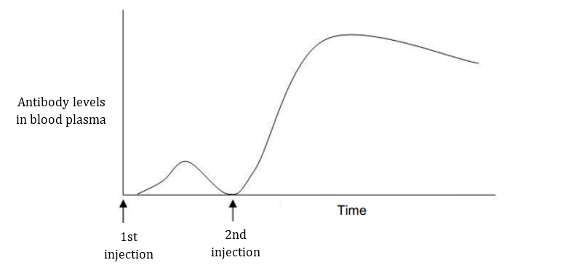

- Name the cells that were stimulated to produce antibodies after the first injection. (1 mark)
___________________________________________________________________________
- Name the type of cell present at the beginning of the second injection but not at the beginning of the first injection. (1 mark)
___________________________________________________________________________
- Using the information from the graph, explain difference between the responses to the first and second injection. (5 marks)
___________________________________________________________________________
___________________________________________________________________________
___________________________________________________________________________
___________________________________________________________________________
___________________________________________________________________________
___________________________________________________________________________
___________________________________________________________________________
___________________________________________________________________________
___________________________________________________________________________

Immunity can be classed as passive or active.
- Contrast active and passive immunity. (2 marks)
___________________________________________________________________________
___________________________________________________________________________
___________________________________________________________________________
___________________________________________________________________________
- Compare the different types of passive and active immunity. (4 marks)
 | Natural | Artificial
Active
Passive

END OF ASSESSMENT

